

**BUDT703:** Database Management Systems

**TEAM**: OnTrack Analytics (BUDT703_0507_15)

**TEAM MEMBERS:** Shriya Goyal, Megha Mudigonda, Rasika Pande, Devika Raheja

**MENTOR:** Prof. Adam Lee

**DATA PROCESSING**

**Dataset Description:**

The data is collected from Amtrak’s official website. The dataset focuses on Amtrak’s operations and customer data (ridership, guest rewards), providing insights into travel patterns, operational efficiency, and service demand across its network. It encompasses data from 2021 to 2023.

**Data Cleaning:**

Using the Amtrak.xlsx file as our foundation, we performed data cleaning to ensure accuracy and usability. This process included correcting typos, standardizing column names, and transforming year columns into rows through unpivoting to streamline analysis. We also filled empty cells with zeros, dropped station city codes that were not present in other sheets such as budget and ridership. Additionally, we enriched the 'stationCity' sheet by incorporating state codes, enabling efficient lookup of station city codes and enhancing the dataset's functionality for subsequent tasks.

**BUSINESS TRANSACTIONS**

1. **Which state has demonstrated the lowest average on-time performance across the years, and how do states rank in terms of their average performance over this three-year period?**

SQL Output:

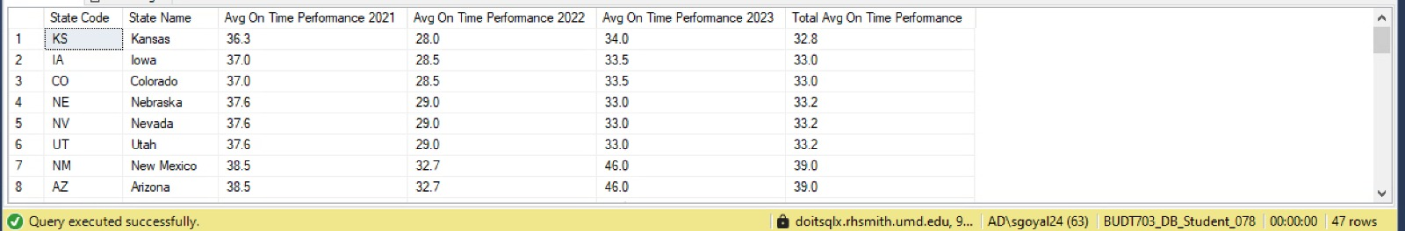

Tableau:

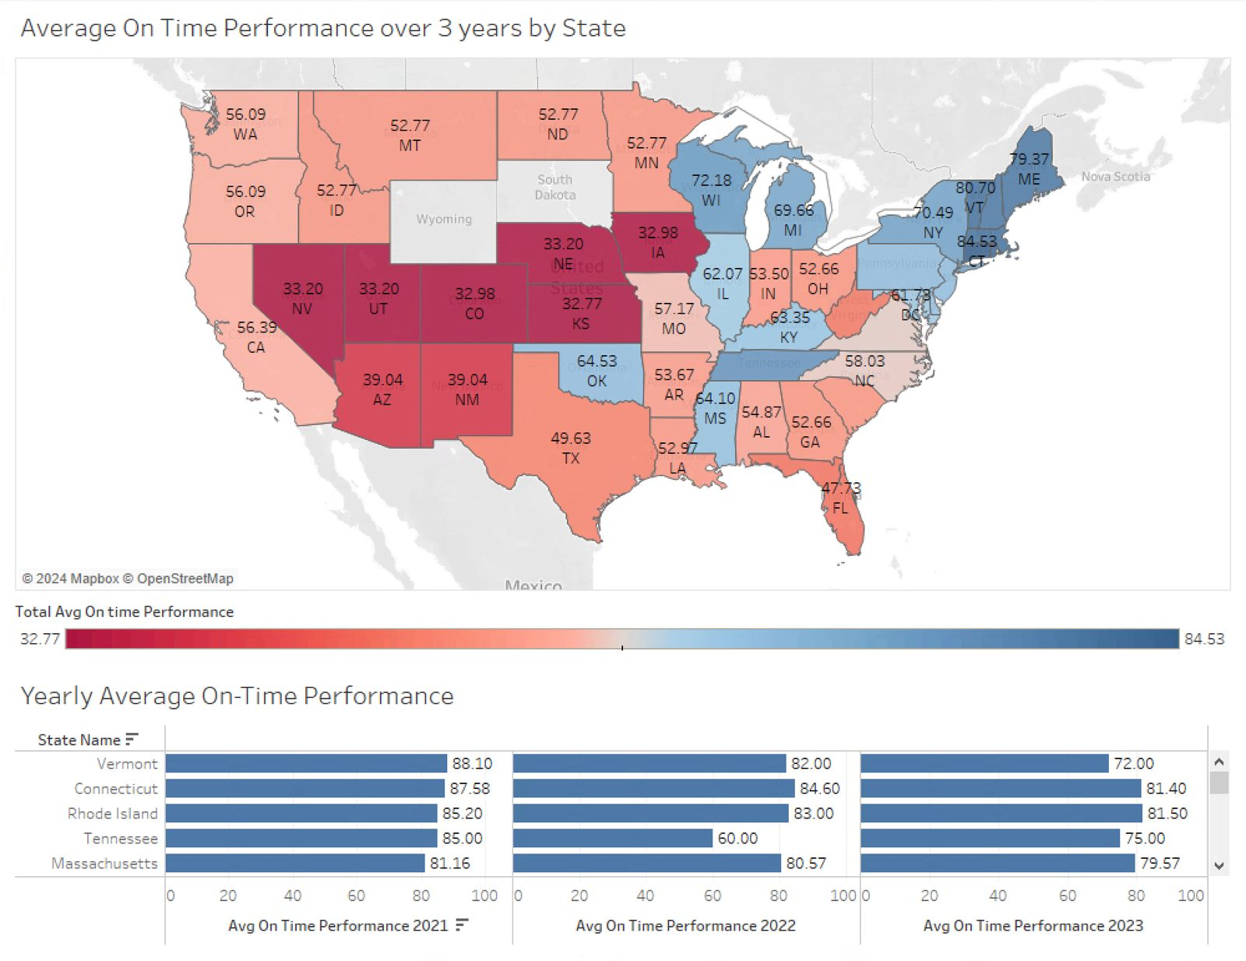

Insights:

It can be inferred that the states that are generally well performing are serviced in the region where Amtrak is the host railroad. Midwest and Southern U.S. states show the worst performance, primarily due to delays caused by shared freight tracks that are more prevalent on the railroads hosted by BNSF, and Union Pacific.

Several factors contribute to these poor performances:

1. Freight Train Interference: A significant cause of delays is the prioritization of freight trains over Amtrak passenger trains. Freight trains are prioritized over Amtrak, causing 70% of delays. While federal law mandates that Amtrak trains receive priority on freight-owned tracks, enforcement is weak, leading to extensive delays.
2. Long-Distance Route Challenges: Amtrak's long-distance routes, which are common in the central U.S., struggle to meet on-time performance metrics. Routes like the California Zephyr , Southwest Chief and Sunset Limited showed particularly poor performance due to reliance on freight-dominated tracks and the vast distances involved.

**2. How do ridership levels compare to Amtrak Guest Rewards enrollment across states, and what patterns can be observed in loyalty program participation relative to passenger trends?**

SQL Output:

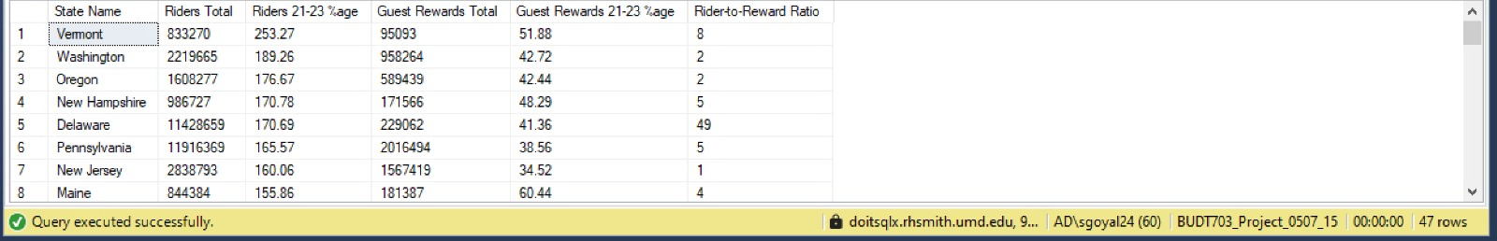

Tableau:

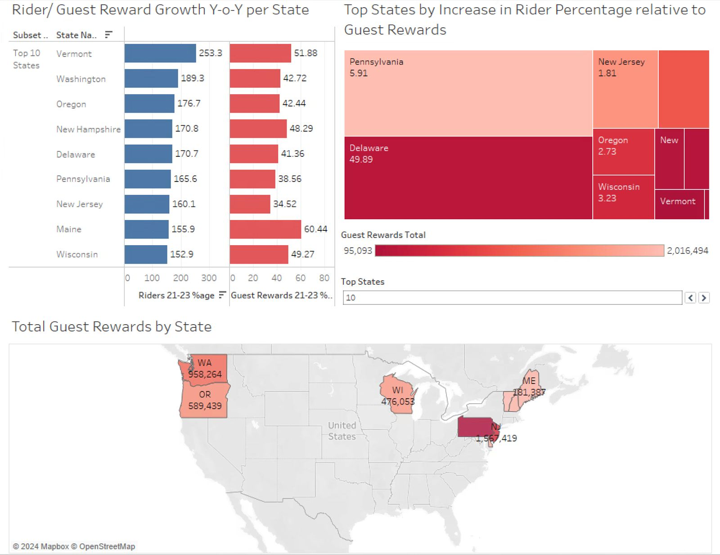

Insights:

We can infer that states like Vermont, Delaware and Pennsylvania see high commuter traffic on Amtrak, particularly along the Northeast Corridor. Also, Pennsylvania tops the list with the highest increase in rider percentage relative to guest rewards (5.91) and Delaware and New Jersey also show notable increases.However, despite having high absolute growth, Vermont, does not show a proportional increase compared to other states.

**3. What is the impact of employment trends in states characterized by consistently high on-time performance, and what patterns or correlations can be identified?**

SQL Output:

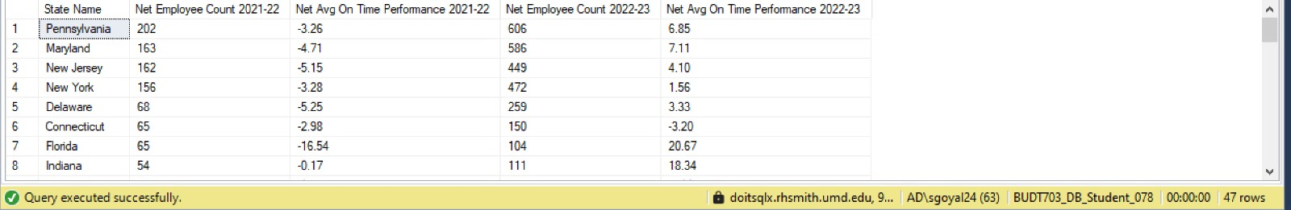

Tableau:

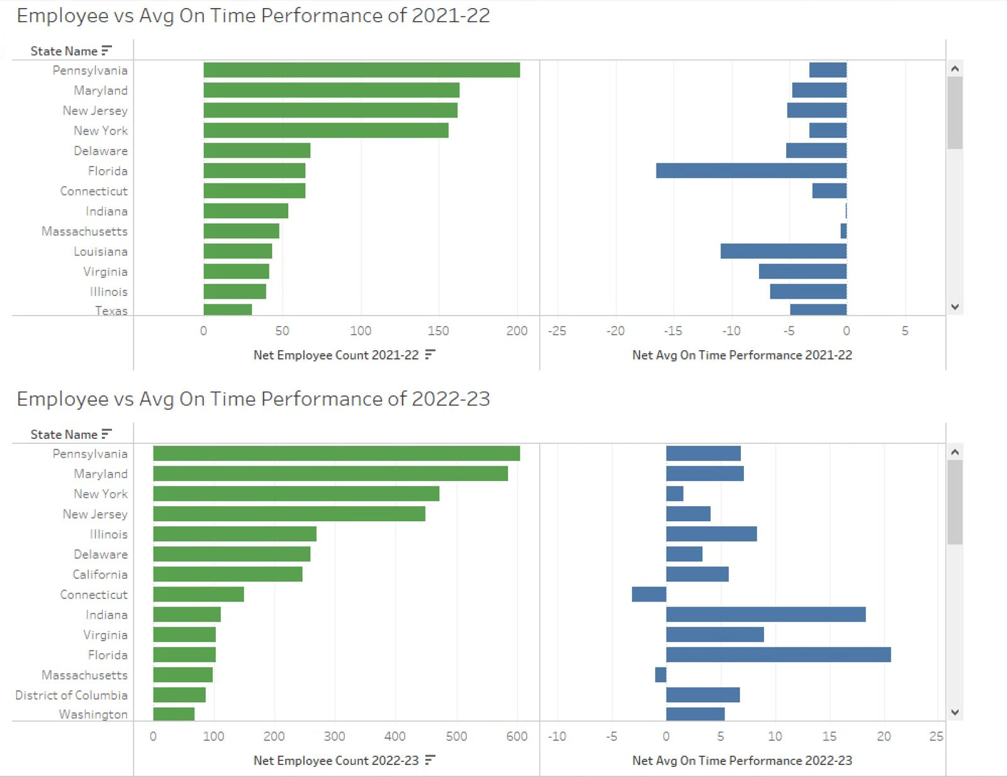

Insights:

To further analyze on-time performance, we looked into factors affecting it beyond the well-documented impact of freight host railroads. The goal was to identify a relationship between employment rates and on-time performance. However, the findings revealed no significant correlation. Despite states with high employment levels, on-time performance remained low in several cases, and no consistent patterns were evident. Unfortunately, the available data did not provide conclusive insights into additional contributing factors.

**4. During the 2022-2023 fiscal year, have states experiencing notable increases in ridership been allocated proportional increases in their budgetary funding to support this growth?**

SQL Output:

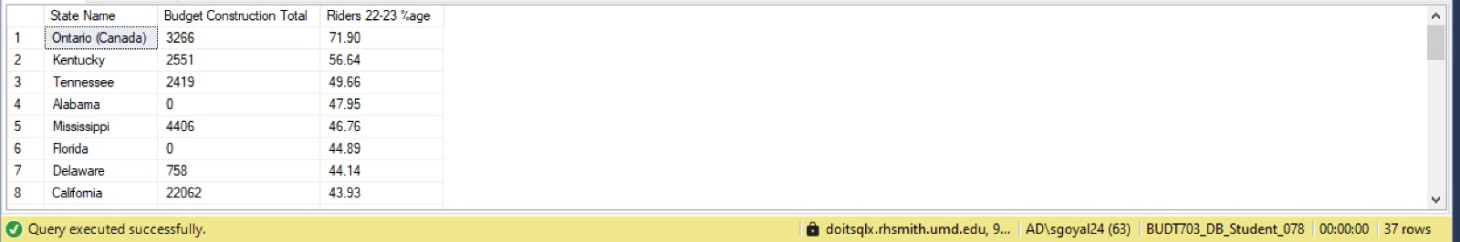

Tableau:

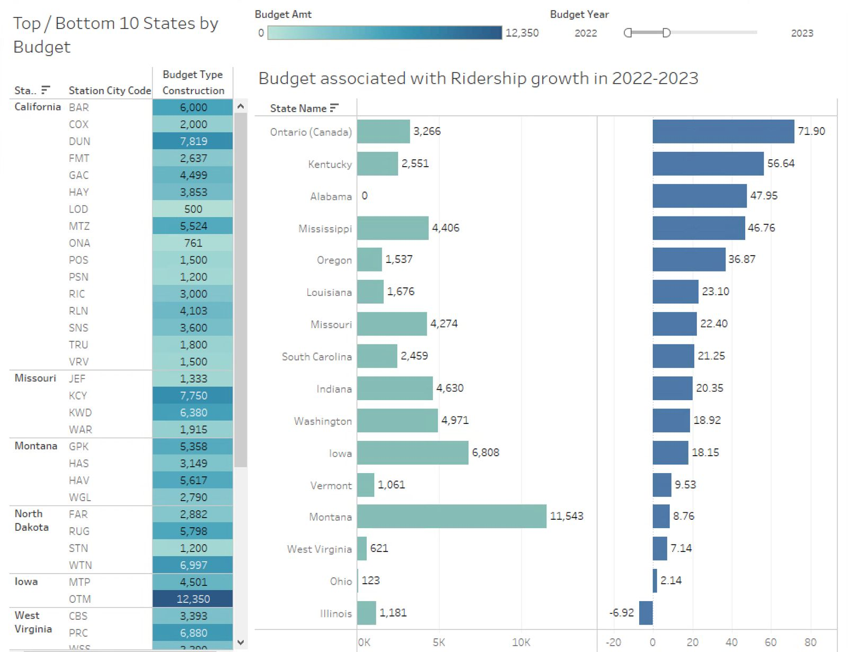

Insights:

States experiencing notable increases in ridership, such as Ontario (71.90%), Kentucky (56.64%), and Alabama (47.95%), have received relatively modest budget allocations. This indicates that areas with rapid ridership growth may not be getting the necessary funding to accommodate the rising demand.

Conversely, Montana saw a lower ridership growth rate of 8.76%, and received one of the highest budget allocations. Ohio, with a mere 2.14% increase in ridership, was allocated $123 million, which appears disproportionate considering their minimal growth. The overfunding of regions with low ridership growth could result in underutilization of resources, as these areas may not need as much immediate financial support for infrastructure or operational enhancements.

The observed funding patterns indicate a disconnect between funding decisions and ridership trends, potentially limiting Amtrak’s ability to effectively address the needs of regions experiencing increased demand.

**RECOMMENDATIONS**

Our analysis highlights key areas affecting Amtrak’s operations and customer experience, focusing on the relationship between operational challenges and opportunities for customer engagement.

* ***Freight Train Interference and On-Time Performance***

A key factor in enhancing on-time performance is addressing the problem of freight train interference. While federal law mandates that Amtrak passenger trains receive priority over freight trains, enforcement has been lax, with the Department of Justice taking only one action in the last 40 years. This lack of accountability enables freight railroads to interfere with Amtrak’s schedules, negatively impacting reliability. It is essential to collaborate with federal authorities to bolster the enforcement of this law, thereby improving operational efficiency and fostering customer trust.

* ***Untapped Potential in Amtrak’s Guest Rewards Program***

Amtrak's Guest Rewards (AGR) program represents a significant opportunity to strengthen customer loyalty and repeat ridership. Expanding on this potential, three key focus areas include:

1. **Targeting Students as a Key Demographic**
   * Amtrak can focus on universities to draw in students, who typically seek affordable and dependable travel options for visiting nearby cities, attending events, or going home during breaks. Partnering with universities to promote AGR through orientation events, campus booths, and special student discounts can be very effective. Tailoring the program with incentives such as free bonus points for sign-ups, low-cost ticket redemptions, and group travel rewards can enhance its appeal to this budget-conscious audience.
2. **Conducting Research to Address Low Enrollment in High-Ridership Areas**
   * In regions where Amtrak is frequently used but Guest Rewards enrollment is low, Amtrak should investigate the reasons for this lack of participation. Conducting surveys and focus groups can help identify whether travelers are unaware of the program, find the benefits unappealing, or perceive it as challenging to join
3. **Enhancing Program Visibility and Accessibility for All Riders**
   * Amtrak can improve its digital presence by highlighting AGR membership on its website and app at every customer interaction. Adding features like automatic enrollment during ticket purchases, real-time tracking of points, and immediate rewards redemption (like snacks on board or Wi-Fi upgrades) can motivate more riders to sign up. Additionally, focused marketing campaigns that showcase the long-term savings and exclusive perks of AGR membership can increase its appeal to occasional travelers.

* ***Distinguish Key Operational Roles***

To enhance operational efficiency, it's crucial to classify employees based on their specific roles, such as engineers, conductors, maintenance staff, and support personnel. This categorization will aid in understanding how the workforce composition affects on-time performance. Although a high overall employee count may obscure shortages in key operational roles, these positions are essential for sustaining efficiency. It's important to examine whether deficiencies in these specific areas influence on-time performance, even when the total employee numbers appear sufficient.

* ***Conduct Needs-Based Assessments***

Combine ridership data with an evaluation of the infrastructure needs in each state (such as station improvements, track capacity, and staffing needs). This approach will help ensure that funds are allocated to the areas that require the most support for the expanding passenger base.

By focusing on operational efficiency and customer engagement, Amtrak can achieve sustainable growth and enhanced competitiveness.

**CITATIONS:**

* State Fact Sheets | Amtrak. (2018). Amtrak.com. <https://www.amtrak.com/about-amtrak/amtrak-facts/state-fact-sheets.html>
* Amtrak Reports & Documents. (n.d.). Www.amtrak.com. <https://www.amtrak.com/about-amtrak/reports-documents.html>
* Amtrak Routes & Stations. (n.d.). Www.amtrak.com. <https://www.amtrak.com/train-routes>
* Great American Stations – Revitalizing America’s Train Stations. (2024). Greatamericanstations.com. <https://www.greatamericanstations.com/>
* Freight Delays and Your Amtrak Service. (2024). Amtrak.com. <https://www.amtrak.com/historical-on-time-performance>
* Amtrak On-Time Performance Trends and Hours of Delay by Cause | Bureau of Transportation Statistics. (n.d.). Www.bts.gov. <https://www.bts.gov/content/amtrak-time-performance-trends-and-hours-delay-cause>
* CY 2023 Host Railroad Report Card & Route On-Time Performance Amtrak grades host railroads based on delay-minutes, but the government’s Metrics and Standards for On-Time. (n.d.). <https://www.amtrak.com/content/dam/projects/dotcom/english/public/documents/corporate/HostRailroadReports/Amtrak-2023-Host-Railroad-Report-Card.pdf>

‌